Dynamic Chaotic–Adversarial Framework for High-Capacity and Imperceptible Image Steganography
Wellia Shinta Sari^{1*}, Christy Atika Sari¹, Safira Hasna Setiyani², Agus Triyono¹, Rabei Raad Ali³

¹Faculty of Computer Science, Universitas Dian Nuswantoro, Imam Bonjol no 207, Pindrikan Kidul, Semarang 50131, Central Java, Indonesia
²Faculty of Law, Management, and Informatics, Universitas Karya Husada, R.Soekanto no 46, Tembalang, Semarang 50276, Central Java, Indonesia
³Faculty of Information Technology and Electrical Engineering, Al-Minassa St., Mosul City, Nineveh Governorate, Iraq
*wellia.shinta@dsn.dinus.ac.id
Abstract. The rapid growth of digital communication has intensified concerns regarding data confidentiality as sensitive information transmitted through multimedia images is increasingly vulnerable to interception and unauthorized analysis. Conventional image steganography methods often struggle to simultaneously achieve high embedding capacity, strong imperceptibility, and resistance to modern steganalysis. To address this challenge, this study proposes a steganographic framework that integrates dynamic logistic chaotic encryption with an adversarial feature-level embedding network. The chaotic sequence is generated using a time-varying logistic map within a highly unstable region, where the control parameter is adaptively derived from a hash-modulated process to produce unpredictable keystreams and strengthen payload security. The encrypted secret image is then embedded through a GAN-based generator guided by a discriminator to preserve natural image characteristics, while a dedicated extractor ensures accurate recovery. Experimental results on multiple standard test images with resolutions of 256 × 256 and 512 × 512 demonstrate high visual fidelity, achieving PSNR values above 58 dB and SSIM values above 0.995, supported by nearly identical histogram distributions between cover and stego images. These findings indicate that the proposed framework provides a promising solution for secure multimedia communication by enabling visually imperceptible and reliably recoverable hidden transmission in digital images.

Keywords: Image steganography, generative adversarial network, chaotic encryption, imperceptibility, deep steganalysis resistance, secure multimedia communication

(Received 2025-12-01, Revised 2026-06-02, Accepted 2026-06-04, Available Online by 2026-08-29)
- Introduction
The ubiquity of multimedia image sharing and online storage has made covert communication both more attractive and more fragile [1]. Hiding data inside pictures is easier to attempt than ever, but keeping that data safe in transit has become harder [2,3]. Traditional methods, such as least significant bit substitution [4] and simple transform-domain embedding methods [5,6], often leave behind subtle fingerprints in pixel statistics or coefficient distributions; those fingerprints may be invisible to the eye but they are fertile ground for forensic tools. Practical channels add another layer of difficulty because compression, noise, and routine image processing can distort or erase embedded bits, so schemes that look good in a clean laboratory setting fail in real deployments [7,8]. At the same time, the drive to increase payload capacity pushes many algorithms to alter images in ways that reduce visual quality or create detectable artifacts, so there is a persistent tug of war between how much can be hidden and how well the cover image is preserved.
Recent advances in machine learning have only sharpened the problem, and deep steganalysis models can pick up on patterns and high-level inconsistencies that earlier detectors missed, making many ostensibly robust schemes vulnerable [9–11]. Moreover, recent developments in transformer-based steganalysis have further increased detection capability by capturing global dependencies and subtle embedding artifacts, making traditional and static embedding schemes increasingly vulnerable. In short, the field faces a threefold challenge, hiding more information, keeping the cover image convincing, and surviving real world transformations, all while staying ahead of ever smarter detection techniques [12–14]. This combination of pressure points shows why designing a steganographic system that is simultaneously secure, high capacity, and robust remains an open and urgent problem [15,16]. Chaotic dynamics provide strong unpredictability, as tiny changes in initial values produce entirely different outputs, enabling secret images to be encrypted in a highly irregular, non-linear manner that is nearly impossible to reconstruct without exact keys [17,18]. Meanwhile, GANs in particular can model natural image statistics and generate visuals indistinguishable from real photographs [19]. In the adversarial setup, one network hides information while another tries to detect it, driving both to improve and producing stego images that maintain high visual quality and smart concealment [14]. Together, chaotic encryption and adversarial generation form a powerful basis for modern steganographic systems with enhanced security, capacity, and resistance to detection.
Several studies have investigated the integration of chaotic encryption and generative models to improve the reliability of image steganography. Research in [20] showed that traditional methods suffer from reduced fidelity and higher detectability at high payloads, proposing CHASE, a chaos-based permutation combined with a GAN encoder–decoder to maintain natural stego appearance and enhance robustness through color-to-grayscale embedding, chaotic permutation, and an invertible design. Study [21] addressed the limited chaotic range of conventional maps by introducing a hybrid chaotic map with dual parameters and embedding in the transform domain, resulting in higher entropy, better imperceptibility, and stronger resistance to statistical attacks. Research in [22] tackled the rigidity of static GANs by using evolutionary optimization to adapt generator and discriminator structures, improving visual realism and resilience against deep steganalysis.
Despite these advances, gaps remain: [20] relies on a fixed architecture with limited adaptability, [21] improves chaos but lacks learned generative modeling, and [22] enhances GAN robustness without including explicit encryption. Overall, existing works show that chaos improves unpredictability and GANs enhance imperceptibility, yet few approaches effectively unify both into a single adaptive framework capable of sustaining fidelity, detection resistance, and reliable recovery across varying conditions. In contrast to these approaches, the proposed method introduces a dynamically modulated chaotic control parameter derived from hash-based adaptation and integrates it within a fully end-to-end adversarial embedding–extraction pipeline. This design enables stronger coupling between encryption unpredictability and embedding imperceptibility, which is not explicitly addressed in prior works.
Our proposed method presents a unified steganographic framework that combines chaotic encryption with a GAN-based encoder–decoder to achieve secure, high-capacity, and imperceptible image hiding. A chaos-driven encryption stage ensures strong randomness, while adversarial learning enables the generation of stego images that remain statistically natural and fully recoverable. The dual-layer protection, consisting of chaotic unpredictability and adversarial imperceptibility, provides improved robustness against compression, noise, and deep-learning-based detection while offering higher capacity and visual quality than prior methods. Based on these challenges, this study aims to answer the following research question: ‘How can a unified steganographic framework effectively integrate dynamic chaotic encryption and adversarial feature-level embedding to simultaneously achieve high embedding capacity, strong imperceptibility, and reliable recovery while maintaining resistance to modern deep-learning-based steganalysis?”.

- Methods

Proposed Pipeline
The proposed system integrates dynamic chaotic encryption and adversarial feature-level embedding into a unified end-to-end steganographic architecture. The overall pipeline consists of four interconnected modules, namely the c Traditional methods such ashaotic encryption block, the generator network, the discriminator, and the extractor network. The process begins with two independent input streams: the cover image $C$ and the secret image $S$. Before any embedding operation is performed, the secret image is transformed by a dynamic logistic chaotic map to enhance unpredictability and resistance to statistical attacks. The chaotic sequence is generated using a time-varying logistic function as calculated using Eq (1), where the control parameter $r_{n}$ is not fixed but dynamically adapted from a hash-derived seed and iteration index, ensuring that the resulting keystream exhibits high entropy and strong sensitivity to initial conditions. This chaotic sequence is mapped to the pixel domain to form an encrypted secret image $E$, which serves as the payload to be embedded. The encrypted secret $E$ and cover image $C$ are then jointly processed by the generator network $G$, a convolutional encoder–decoder architecture that learns to fuse the information of both inputs at the feature level. Instead of relying on predefined embedding rules, the generator adaptively distributes the encrypted payload across the spatial structure of the cover image through learned feature modulation. Formally, the generator produces a stego image $C^{'}=G(C,E),$ where $C^{'}$ is constrained to remain visually and statistically close to the original cover. To enforce this constraint, a convolutional discriminator $D$ is trained adversarially to distinguish between real cover images and generated stego images. During training, the discriminator minimizes the binary cross entropy loss as calculated using Eq (2). While the generator simultaneously optimizes a hybrid loss that encourages both imperceptibility and reliable decoding as calculated using Eq (3), where $L_{adv}=-log⁡D(C^{'})$enforces adversarial realism, and $L_{rec}$ensures that the extractor can reconstruct the encrypted secret accurately. The extractor network $E_{x}(⋅)$receives the stego image $C^{'}$and predicts the reconstructed encrypted secret $\hat{E}=E_{x}(C^{'}),$ which is subsequently passed through the inverse chaotic process to obtain the recovered secret $\hat{S}$. The reconstruction loss is computed using Eq (4).
This ensures pixel-level fidelity of the payload. Because the chaotic encryption and decryption processes are bijective and highly sensitive to mismatched parameters, even minimal degradation in the reconstructed encrypted secret results in significant distortion in the final recovered secret, which forces the generator and extractor to optimize toward highly accurate embedding and extraction. Through end-to-end training, the entire architecture jointly learns to maximize embedding capacity, minimize visual distortion, and maintain strict recoverability of the chaotic-encrypted data. The complete pipeline therefore enables a high-security and high-imperceptibility steganographic system that leverages the complementary strengths of dynamic chaos and adversarial learning. The proposed pipeline can be seen in Figure 1.

$x_{n+1}=r_{n}x_{n}(1-x_{n})$ (1)
$L_{D}=-E[log⁡D(C)]-E[log⁡(1-D(C^{'}))],$ (2)
$L_{G}=λ_{adv}L_{adv}+λ_{rec}L_{rec}+λ_{sim}∥C-C^{'}∥_{2}^{2}$ (3)
$L_{rec}=∥E-\hat{E}∥_{1}$ (4)

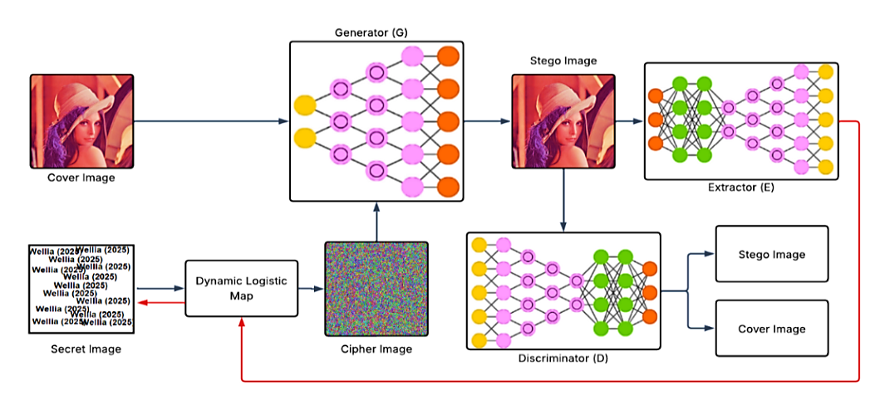
Figure 1. Proposed pipeline

The embedding capacity in the proposed framework is implicitly determined by the size of the encrypted secret relative to the cover image, enabling flexible payload adaptation. Unlike fixed-rate embedding schemes, the proposed method operates at the image level, where the payload is distributed across feature representations rather than explicitly defined per pixel, allowing a balance between capacity and imperceptibility.

Dynamic Logistic Encryption
The chaotic encryption module converts the secret image into a cipher representation that exhibits high unpredictability and strong diffusion characteristics before it is embedded into the cover image [23]. Building upon the time-varying logistic recurrence previously defined in Eq. (1), the proposed method incorporates a dynamic control strategy in which the logistic parameter is adaptively modified at every iteration. This approach significantly intensifies the chaotic behavior, broadens the effective parameter space, and prevents the system from entering short periodic cycles that may appear in traditional fixed-parameter maps. The secret image $S$ is reshaped into a one-dimensional vector $s=\{s_{i}\}_{i=1}^{N}$, where $N=H×W×3$. A SHA-256 hash of the raw pixel stream is computed and used to derive the initial chaotic state $x_{0}$together with a sequence of auxiliary coefficients. These hash-derived values introduce strong input dependence, ensuring that even minimal modifications in the secret image lead to substantial changes in the chaotic trajectory. The adaptive logistic control parameter is calculated using Eq. (5), where $h_{k}$ denotes the $k$-th byte of the SHA-256 digest with $k=n mod 32$.

$r_{n}=3.8+0.2(\frac{h_{k}+n+⌊{10}^{6}x_{n}⌋}{255} mod 1)$ (5)
By allowing $r_{n}$ to vary with the iteration index, the hash components, and the evolving chaotic state itself, the system generates a non-stationary chaotic sequence that exhibits significantly stronger sensitivity than classical logistic iterations. The resulting values $\{x_{n}\}_{n=1}^{N}$ are then projected onto the byte range through Eq. (6), forming the keystream $K=\{k_{n}\}_{n=1}^{N}$. Pixel-level encryption is performed using the diffusion operation $E_{n}=s_{n}⊕k_{n}$, producing the encrypted secret vector $E$, which is later reshaped back into an RGB tensor. Since the encryption relies on the recurrence in Eq. (1) together with the adaptive modulation rule in Eq. (5), any deviation in the initial state $x_{0}$, the hash-derived coefficients, or the iteration index results in a completely different chaotic trajectory due to exponential divergence. This characteristic ensures strong resistance to brute-force, statistical, and chosen-plaintext attacks, making the chaotic cipher suitably robust for the subsequent adversarial embedding process.

$k_{n}=⌊(x_{n}×{10}^{8}) mod 256⌋$ (6)
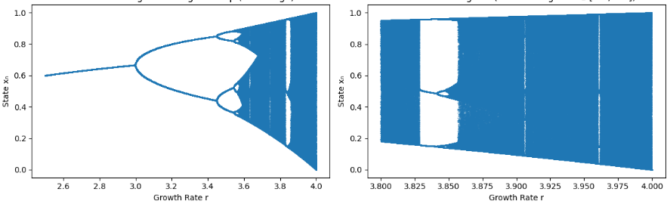
(a) Bifurcation Diagram of Logistic Map (Full Range) | (b) Bifurcation Diagram (Chaotic Region r ∈ [3.8, 4.0])
Figure 2. Bifurcation diagram of chaotic regions

As seen in Figure 2, the logistic map exhibits distinct dynamical behaviors as the control parameter r varies. Figure 2(a) provides the full bifurcation structure, illustrating the classical progression from stable fixed points to successive period-doubling bifurcations and eventually to fully developed chaotic motion as r approaches four. This broad view is presented to establish the nonlinear foundation of the logistic system. In contrast, Figure 2(b) isolates the specific chaotic interval $r ∈ [3.8,4.0]$, which is explicitly adopted in our proposed encryption module. This region displays dense and irregular orbit distributions, intermittent periodic windows, and significant sensitivity to initial conditions, properties that are essential for generating a cryptographically strong keystream. Because this chaotic band maximizes unpredictability and ensures rapid divergence of trajectories, the proposed method leverages the behavior observed in Figure 2(b) as the operational domain for constructing the dynamic logistic sequence used to encrypt the secret image. The security strength of the proposed chaotic encryption is supported by the high sensitivity of the dynamic logistic map to initial conditions and hash-derived parameters, which significantly expands the effective keyspace. The use of SHA-256 further ensures strong diffusion and resistance to brute-force and statistical attacks, contributing to a high level of entropy in the generated keystream.

Generative Adversarial Network (GAN)
The generator serves as the core embedding module of the proposed steganographic framework and is responsible for fusing the cover image and the chaotic encrypted secret at the feature level [24]. Unlike classical embedding rules that rely on explicit modifications of pixel intensities, the generator employs a fully learnable convolutional encoder–decoder architecture that adapts its embedding strategy through end-to-end adversarial training. This design allows the network to distribute the payload in a spatially coherent and perceptually aligned manner while maintaining high fidelity to the original cover image. The generator receives two inputs, namely the cover image $C$ and the encrypted secret $E$. Both inputs are first processed through separate shallow convolutional branches to extract low-level representations, calculated using Eq. (7), where $ϕ_{C}$and $ϕ_{E}$represent convolutional feature extractors designed to capture structural and textural information from the cover and encrypted secret respectively. These features are then concatenated channel-wise to form a joint representation by Eq. (8). This fusion initiates the embedding process by allowing the network to consider the encrypted payload in the context of the spatial structure of the cover image. To further enhance representational richness, $F_{0}$is passed through a stack of residual convolutional blocks. Each block can be calculated using Eq. (9), where $W_{1,i}$and $W_{2,i}$ denote learnable convolutional kernels, $*$represents convolution, and $σ$ is a nonlinear activation function.

$F_{C}=ϕ_{C}(C),F_{E}=ϕ_{E}(E)$ (7)
$F_{0}=\text{concat}(F_{C},F_{E})$ (8)
$F_{i+1}=F_{i}+σ\text{ , }(W_{2,i}*σ(W_{1,i}*F_{i})),$ (9)

The residual structure facilitates stable gradient propagation and enables the generator to model complex dependencies between cover content and encrypted features without causing over-embedding or perceptual distortion. Once the deep fused representation is established, the generator transforms this feature set back into the spatial domain through a decoding module that reconstructs an RGB image. The final stego image is expressed as $C^{'}=G(C,E),$ where $G$denotes the complete generator network. To ensure that the output retains the perceptual characteristics of the cover, the reconstruction pathway incorporates a similarity constraint enforced during training. This ensures that the mapping from $(C,E)$to $C^{'}$preserves the global color distribution and local edge structure of the original cover while embedding the encrypted secret within its deeper feature layers.
The generator architecture consists of an encoder–decoder structure with multiple convolutional layers, where each convolution uses a kernel size of 3 × 3 and is followed by a ReLU activation function. Residual blocks are incorporated to stabilize training and improve feature fusion between the cover image and encrypted secret. The discriminator is implemented as a convolutional classifier with progressively increasing feature depth and LeakyReLU activations. The network is trained using the Adam optimizer with a learning rate of 0.0002 for both generator and discriminator over multiple epochs until convergence.

Performance Metric
To evaluate the imperceptibility of the proposed steganographic framework, two widely used objective metrics are employed, namely the peak signal-to-noise ratio (PSNR) and the structural similarity index measure (SSIM) [25]. These metrics quantify how closely the generated stego image resembles the original cover image, which is a critical requirement in image steganography [26]. An effective embedding method should introduce only minimal distortion so that the presence of hidden information remains visually undetectable to human observers and statistically difficult to identify by automated steganalysis. PSNR captures pixel-level fidelity, whereas SSIM evaluates perceptual and structural consistency, allowing both low-level and high-level changes to be considered in the assessment [27,28]. The PSNR is derived from the mean squared error (MSE), which measures the average intensity difference between the cover image $C$and the corresponding stego image $C^{'}$. A smaller MSE indicates that the embedding process has introduced minimal perturbations. The MSE is calculated using Eq. (10).
Based on the MSE, the PSNR is computed to express imperceptibility in decibels. Higher PSNR values correspond to better preservation of visual quality. PSNR is calculated by Eq. (11), where $L=255$ represents the maximum pixel intensity for 8-bit images. Because the generator is trained to minimize distortion while preserving structural features, a high PSNR reflects effective feature-level embedding. While PSNR assesses global pixel differences, SSIM evaluates the similarity of local structural information, luminance, and contrast between the cover and stego images. SSIM reflects human visual perception more accurately, making it particularly important for verifying that the embedded payload does not introduce noticeable artifacts or distortions. Given two image patches $x$and $y$, the SSIM index is calculated by Eq. (12), where $μ_{x}$and $μ_{y}$represent local means, $σ_{x}^{2}$and $σ_{y}^{2}$are variances, $σ_{xy}$is the covariance, and $c_{1}$and $c_{2}$are stabilizing constants. SSIM values close to 1.0 indicate a high degree of structural similarity. In the context of steganography, achieving SSIM values above 0.95 suggests that the embedding process is visually imperceptible.

$\text{MSE}=\frac{1}{HW}\sum_{i=1}^{H}{ \sum_{j=1}^{W}{{(C(i,j)-C^{'}(i,j))}^{2}}}$ (10)
$\text{PSNR}=10{log⁡}_{10}(\frac{L^{2}}{\text{MSE}}),$ (11)
$\text{SSIM}(x,y)=\frac{(2μ_{x}μ_{y}+c_{1})(2σ_{xy}+c_{2})}{(μ_{x}^{2}+μ_{y}^{2}+c_{1})(σ_{x}^{2}+σ_{y}^{2}+c_{2})}$ (12)
- Results and Discussion

Visual Stego Analysis
The visual evaluation assesses the perceptual quality of the stego images produced by the proposed framework. Figure 3 shows the original cover images, while Figure 4 presents the corresponding stego results used to visually inspect whether embedding introduces distortions, color shifts, or structural artifacts. To complement this assessment, Figure 5 compares the histogram distributions of cover and stego images to identify any changes in intensity patterns. Visual comparison shows that the stego images in Figure 4 remain indistinguishable from their cover counterparts, with fine textures, contours, and high-frequency details preserved across all test samples, indicating that the adversarial embedding maintains strong perceptual fidelity. However, qualitative inspection alone cannot fully confirm whether subtle pixel-level deviations are present. To further verify imperceptibility, the intensity distributions of cover and stego images are compared using histograms, as shown in Figure 5, with the Barbara image illustrating their statistical similarity.

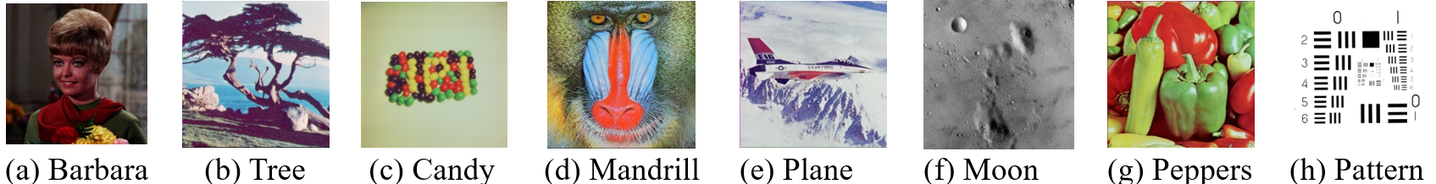
Figure 3. Cover image

Figure 4. Stego images

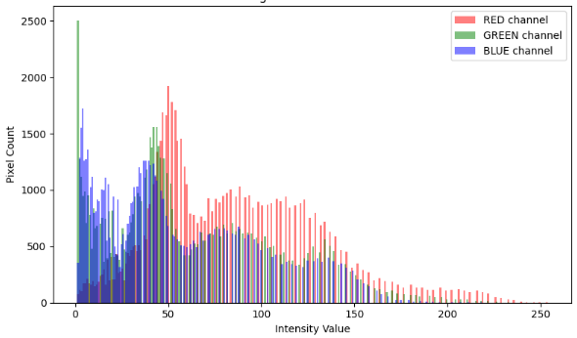
(a) Cover Histogram | (b) Stego Histogram
Figure 5. Histogram comparison between the cover and stego versions of the Barbara image

Following the histogram comparison, the nature of the secret image used in this study is clarified. Instead of using a public dataset, the secret image is custom-initialized by the authors to ensure full control over the embedded content. As shown in Figure 6, the secret image contains repeated text patterns representing the payload, which are then encrypted using the dynamic logistic chaotic map before embedding. The visual and statistical evaluations show that the proposed steganographic framework preserves fine textures, color consistency, structural details, and global intensity distributions across different cover images. These results indicate that the adversarial generator successfully embeds the chaotic encrypted payload without introducing visible artifacts or significant statistical distortions, thereby confirming strong imperceptibility and providing a solid basis for the subsequent evaluation.

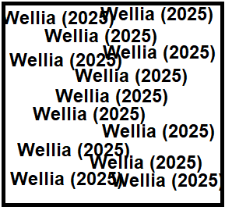 | 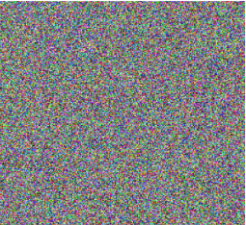
(a) Secret Image | (b) Chaotic Secret Image
Figure 6. Secret image used in the embedding process

Metrics Evaluation
As shown in Table 1, the proposed method exhibits consistently high imperceptibility across all test images, with PSNR and SSIM values remaining within a narrow and favorable range for both resolutions. For images resized to 256 × 256, the average PSNR reaches 59.22 dB, while the average SSIM is 0.9965, indicating that the stego images are nearly indistinguishable from their respective covers at the pixel and structural levels. When the resolution increases to 512 × 512, the performance improves even further, with an average PSNR of 60.28 dB and an average SSIM of 0.9980. The slightly higher values at larger resolutions reflect the generator’s ability to distribute the embedded information more smoothly over a greater number of pixels, reducing the relative distortion introduced during the embedding process. Execution times also scale proportionally with resolution, yet remain within an efficient range, demonstrating that the model balances high fidelity with computational practicality.
The consistently high PSNR and SSIM values can be attributed to the feature-level embedding strategy, where the generator distributes the encrypted payload across spatial and structural representations rather than concentrating modifications at specific pixel locations. This reduces local distortion and preserves both global luminance and fine texture details. Although a direct comparison with specific baseline methods is not included in this study, the achieved PSNR and SSIM values are significantly higher than commonly reported ranges in conventional and deep-learning-based steganographic approaches, indicating competitive performance in terms of imperceptibility. In the context of modern steganalysis, particularly CNN-based and transformer-based detectors, the near-identical histogram distributions and high structural similarity suggest that the proposed method introduces minimal statistical and perceptual deviations. While a dedicated steganalysis attack evaluation is not conducted, the observed characteristics indicate potential resistance to detection models that rely on distributional and feature-level inconsistencies. Although explicit robustness tests under compression or noise are not performed, the consistent performance across diverse images indicates strong generalization of the embedding mechanism. Overall, the quantitative findings reinforce the visual observations presented earlier, confirming that the integration of dynamic chaotic encryption and adversarial embedding results in stego images with exceptionally high fidelity. The consistently elevated PSNR and SSIM values across diverse image textures demonstrate the robustness of the generator in preserving both global appearance and fine structural details. These results verify that the proposed framework achieves a level of imperceptibility that is difficult to detect using traditional statistical or perceptual measures, thereby validating its effectiveness as a secure and visually seamless steganographic solution.

Table 1. Performance evaluation results
Stego Image | Image 256 x 256 |  |  | Image 512 x 512
Stego Image | PSNR | SSIM | Execution Time | PSNR | SSIM | Execution Time
Barbara | 59.83 dB | 0.9971 | 0.28 s | 60.92 dB | 0.9983 | 0.63 s
Tree | 58.74 dB | 0.9965 | 0.26 s | 59.88 dB | 0.9979 | 0.58 s
Candy | 60.41 dB | 0.9978 | 0.31 s | 61.55 dB | 0.9987 | 0.66 s
Mandrill | 58.03 dB | 0.9954 | 0.34 s | 59.14 dB | 0.9968 | 0.75 s
Plane | 59.22 dB | 0.9968 | 0.25 s | 60.47 dB | 0.9982 | 0.59 s
Moon | 58.91 dB | 0.9961 | 0.27 s | 60.02 dB | 0.9974 | 0.61 s
Peppers | 60.12 dB | 0.9976 | 0.29 s | 61.34 dB | 0.9985 | 0.64 s
Pattern | 58.45 dB | 0.9959 | 0.33 s | 59.71 dB | 0.9972 | 0.71 s

Discussion
Existing studies highlight progress in combining chaos and generative models for steganography. Research in [20] proposed CHASE, which uses chaotic permutation and an adversarial encoder–decoder to maintain realism at high payloads, offering an invertible architecture that balances capacity and imperceptibility. Research [21] enhanced randomness and security through a hybrid chaotic map with dual parameters embedded in the transform domain, improving entropy and resistance to statistical attacks. Research in [22] introduced an evolutionary GAN framework that adapts generator and discriminator structures, strengthening robustness to compression, resizing, and deep-learning detection. Building on these foundations, the proposed method advances the field by integrating dynamic chaotic encryption with adversarial feature-level embedding. It employs a time-varying logistic map with hash-driven adaptive parameters for a highly unpredictable keystream and embeds the encrypted payload directly in the feature space, achieving near-lossless reconstruction with high PSNR and SSIM. A dedicated extractor ensures end-to-end recovery, while histogram consistency and robustness across diverse textures establish the framework as a highly imperceptible and secure improvement over prior chaotic- and GAN-based approaches.
- Conclusion
This study presents a steganographic framework that integrates dynamic logistic chaotic encryption with adversarial feature-level embedding to achieve high imperceptibility and reliable image recovery. The use of a time-varying logistic map enhances the unpredictability of the encryption process, while the GAN-based embedding mechanism preserves visual quality through adaptive feature fusion. Experimental results demonstrate strong performance in terms of visual fidelity, achieving PSNR values above 58 dB and SSIM values exceeding 0.995, with minimal statistical deviation between cover and stego images. The proposed approach provides an effective balance between security, capacity, and imperceptibility, supported by the integration of chaotic dynamics and adversarial learning. While the results indicate promising resistance to statistical and perceptual detection, further evaluation under dedicated steganalysis attacks and robustness testing remains an important direction for future work. Future studies may also explore higher embedding capacities, robustness against compression and real-world distortions, and the incorporation of more advanced generative architectures to improve generalization and adaptability.

Declaration of AI and AI assisted technologies in the writing process
During the preparation of this work, the authors used ChatGPT to assist with language refinement and grammatical editing. After using this tool, the authors reviewed and edited the content as needed and take full responsibility for the content of the publication.

Declaration of Competing Interest
The authors declare that they have no competing financial interests or personal relationships that could have influenced the work presented in this paper.

Acknowledgements
This research was funded by the Universitas Dian Nuswantoro Research Grant under Decree No. 241/F.9/UDN-09/X/2025.
References
[1] Liu C, Zhu T, Zhang J, Zhou W. Privacy Intelligence: A Survey on Image Privacy in Online Social Networks. ACM Comput Surv 2023;55:1–35. https://doi.org/10.1145/3547299.
[2] Min-Allah N, Nagy N, Aljabri M, Alkharraa M, Alqahtani M, Alghamdi D, et al. Quantum Image Steganography Schemes for Data Hiding: A Survey. Applied Sciences (Switzerland) 2022;12. https://doi.org/10.3390/app122010294.
[3] Tripathi A, Prakash J. A blockchain enabled reversible data hiding based on image smoothing and interpolation. Multimed Tools Appl 2023. https://doi.org/10.1007/s11042-023-16695-x.
[4] Rohini M, Srikanth MA, Prajwal M, Kumar PR, Basavaraj M, Vinay MU. Advanced Data Security Using Modulo Operator And LSB Method. Journal of Scholastic Engineering Science and Management 2023;2023:26–37. https://doi.org/10.5281/zenodo.7890771ï.
[5] Maiti C, Dhara BC, Umer S, Asari V. An Efficient and Secure Method of Plaintext-Based Image Encryption Using Fibonacci and Tribonacci Transformations. IEEE Access 2023;11:48421–40. https://doi.org/10.1109/ACCESS.2023.3276723.
[6] Alomoush W, Khashan OA, Alrosan A, Attar HH, Almomani A, Alhosban F, et al. Digital image watermarking using discrete cosine transformation based linear modulation. Journal of Cloud Computing 2023;12. https://doi.org/10.1186/s13677-023-00468-w.
[7] Fryer J, Garcia P. The Good, the Bad and the Ugly: Practices and Perspectives on Hardware Acceleration for Embedded Image Processing. J Signal Process Syst 2023;95:1181–201. https://doi.org/10.1007/s11265-023-01885-5.
[8] Gupta N, Vijay R. Hybrid image compression-encryption scheme based on multilayer stacked autoencoder and logistic map. China Communications 2022;19:238–52. https://doi.org/10.23919/JCC.2022.01.017.
[9] Wani MA, Sultan B. Deep learning based image steganography: A review. WIREs Data Mining and Knowledge Discovery 2023;13. https://doi.org/10.1002/widm.1481.
[10] Yang A, Bai Y, Xue T, Li Y, Li J. A novel image steganography algorithm based on hybrid machine leaning and its application in cyberspace security. Future Generation Computer Systems 2023;145:293–302. https://doi.org/10.1016/j.future.2023.03.035.
[11] Sari CA, Rachmawanto EH, Isinkaye FO, Ali RR. Symmetric Image Encryption Using Chaotic Logistic Map and Deep Convolutional Feature Learning. International Journal of Safety and Security Engineering 2025;15:1369–77. https://doi.org/10.18280/ijsse.150704.
[12] Jiang J-W, Zhang T, Li W, Wang S-M. A Quantum Image Watermarking Scheme Based on Quantum Hilbert Scrambling and Steganography about the Moiré Fringe. Quantum Engineering 2023;2023:1–12. https://doi.org/10.1155/2023/3746357.
[13] Kumar M, Soni A, Shekhawat ARS, Rawat A. Enhanced Digital Image and Text Data Security Using Hybrid Model of LSB Steganography and AES Cryptography Technique. 2022 Second International Conference on Artificial Intelligence and Smart Energy (ICAIS), IEEE; 2022, p. 1453–7. https://doi.org/10.1109/ICAIS53314.2022.9742942.
[14] Adee R, Mouratidis H. A Dynamic Four-Step Data Security Model for Data in Cloud Computing Based on Cryptography and Steganography. Sensors 2022;22. https://doi.org/10.3390/s22031109.
[15] Li J, Wang K, Jia X. A Coverless Audio Steganography Based on Generative Adversarial Networks. Electronics (Basel) 2023;12:1253. https://doi.org/10.3390/electronics12051253.
[16] Shtayt BA, Zakaria NH, Harun NH. A comprehensive review on medical image steganography based on LSB technique and potential challenges. Baghdad Science Journal 2021;18:957–74. https://doi.org/10.21123/bsj.2021.18.2(Suppl.).0957.
[17] Thalapathiraj S, Arunnehru J, Bharathi VC, Dhanasekar R, Vijayaraja L, Kannadasan R, et al. A novel approach for encryption and decryption of digital imaging and communications using mathematical modelling in internet of medical things. The Journal of Engineering 2024;2024. https://doi.org/10.1049/tje2.70038.
[18] Ahmed ST, Hammood DA, Chisab RF, Al-Naji A, Chahl J. Medical Image Encryption: A Comprehensive Review. Computers 2023;12:160. https://doi.org/10.3390/computers12080160.
[19] Zhang R, Shu R, Wei Y, Zhang H, Wu X. A Novel S-Box Generation Methodology Based on the Optimized GAN Model. Computers, Materials & Continua 2023;76:1911–27. https://doi.org/10.32604/cmc.2023.041187.
[20] Huo L, Chen R, Wei J, Huang L. A High-Capacity and High-Security Image Steganography Network Based on Chaotic Mapping and Generative Adversarial Networks. Applied Sciences 2024;14:1225. https://doi.org/10.3390/app14031225.
[21] Sharafi J, Khedmati Y, Shabani MM. Image steganography based on a new hybrid chaos map and discrete transforms. Optik (Stuttg) 2021;226:165492. https://doi.org/10.1016/j.ijleo.2020.165492.
[22] Martín A, Hernández A, Alazab M, Jung J, Camacho D. Evolving Generative Adversarial Networks to improve image steganography. Expert Syst Appl 2023;222:119841. https://doi.org/10.1016/j.eswa.2023.119841.
[23] Wang M, Wang X, Wang C, Zhou S, Xia Z, Li Q. Color image encryption based on 2D enhanced hyperchaotic logistic-sine map and two-way Josephus traversing. Digit Signal Process 2023;132:103818. https://doi.org/10.1016/j.dsp.2022.103818.
[24] Bhat R, Nanjundegowda R. CryptoGAN: a new frontier in generative adversarial network-driven image encryption. IAES International Journal of Artificial Intelligence (IJ-AI) 2024;13:4813. https://doi.org/10.11591/ijai.v13.i4.pp4813-4821.
[25] Sari CA, Dzaki MH, Rachmawanto EH, Ali RR, Doheir M. High PSNR Using Fibonacci Sequences in Classical Cryptography and Steganography Using LSB. International Journal of Intelligent Engineering and Systems 2023;16:568–80. https://doi.org/10.22266/ijies2023.0831.46.
[26] Himthani V, Dhaka VS, Kaur M, Rani G, Oza M, Lee H-N. Comparative performance assessment of deep learning based image steganography techniques. Sci Rep 2022;12:16895. https://doi.org/10.1038/s41598-022-17362-1.
[27] Kaur S, Singh S, Kaur M, Lee H-N. A Systematic Review of Computational Image Steganography Approaches. Archives of Computational Methods in Engineering 2022;29:4775–97. https://doi.org/10.1007/s11831-022-09749-0.
[28] Sofyan EA, Sari CA, Rachmawanto H, Cahyo RD. High-Quality Evaluation for Invisible Watermarking Based on Discrete Cosine Transform (DCT) and Singular Value Decomposition (SVD). Advance Sustainable Science, Engineering and Technology (ASSET) 2024;6. https://doi.org/10.26877/asset.v6i1.17186.

