**Identification Of Student Misconceptions On The Digestive System Material Class VIII Madrasah Tsanawiyah**

**Chabibah*, Siti Patonah, Harto Nuroso**

Magister Pendidikan IPA, Pascasarjana, Universitas PGRI Semarang

|  |  |
| --- | --- |
| **Article Information** | **Abstract** |
| **History:**  Received: 05/05/2024  Accepted: 18/05/2024  Published: 30/04/2024  **Corresponding Author:**  Author Name*: Chabibah  Email*: [tiarakholiq@gmail.com](mailto:tiarakholiq@gmail.com) | ***Abstract:*** *In the process of learning Science in schools, students often experience misconceptions regarding the digestive system material. This research aims to identify students' misconceptions about the digestive system material and determine the contributing factors. This study employs a survey research design with purposive sampling from class VIII B at MTs Fatahillah. The data collection method involves essay tests, the Certainty Response of Index (CRI) technique, and interviews. Data analysis determines the CRI value for each student's response to essay questions based on a 0-5 scale. The findings of this research reveal that the average percentage of misconceptions in the digestive system is 29%, categorized as low. Four concepts within the digestive system material exhibit misconceptions: digestive organs (12.4%), digestive system processes (23.4%), digestive system disorders (22%), and preventive measures for digestive system diseases (18%). The factors contributing to misconceptions originate from students, teachers, textbooks, and teaching strategies. The implications of this research can assist teachers in improving the quality of teaching, enhancing student understanding, and creating a more effective learning environment.*  ***Keywords:*** *Misconceptions, Digestive System, Madrasah*  ***Abstrak:*** *Dalam proses pembelajaran IPA di sekolah, siswa seringkali mengalami miskonsepsi materi sistem pencernaan. Tujuan penelitian untuk mengidentifikasi miskonsepsi siswa dalam materi sistem pencernaan dan mengidentifikasi faktor penyebabnya. Penelitian ini termasuk penelitian survey dengan purposive sampling kelas VIII B MTs Fatahillah. Metode pengumpulan data digunakan tes uraian dengan teknik Certainty Response of Index (CRI) dan wawancara. Teknik analisis data dilakukan dengan cara menentukan nilai CRI pada setiap jawaban siswa pada soal-soal uraian berdasarkan pada skala 0-5. Hasil penelitian ini menemukan bahwa rata-rata persentase miskonsepsi pada sistem pencernaan sebesar 29% atau kategori rendah. Terdapat empat konsep materi sistem pencernaan yang mengalami miskonsepsi yaitu organ pencernaan (12.4%), proses sistem pencernaan (23.4%), gangguan sistem pencernaan (22%), upaya pencegahan penyakit sistem pencernaan (18%). Sedangkan faktor penyebab miskonsepsi berasal dari siswa, guru, buku teks dan strategi pembelajaran guru. Implikasi penelitian ini dapat membantu guru meningkatkan kualitas pembelajaran ulitas pembelajaran, memperbaiki pemahaman siswa, dan menciptakan lingkungan pembelajaran yang lebih efektif.*  ***Kata kunci:*** *Miskonsepsi, Sistem Pencernaan, Madrasah* |
| **How to Cite:**  Chabibah, Siti Patonah, Harto Nuroso. (2024). Identisifikasi Miskonsepsi Siswa Pada Materi Sistem Pencernaan Kelas VIII Madrasah Tsanawiyah. **Journal of Sustainabel and Science Education (JSSE)** 1(1), 19-28. doi: 10.25134/esj.v11i2.1863 | |

1. **INTRODUCTION**

In the national curriculum, science learning is directed to develop students' understanding of various phenomena, concepts, and principles of natural sciences (Iwantara *et al*., Safitri *et al*, 2018). Conceptual understanding is the first step in shaping students' knowledge structures, because a strong understanding of basic concepts, students can build more complex and integrated knowledge (Liu & Fang, 2023). Functionally, a good conceptual understanding provides a solid foundation for advanced learning and the development of skills necessary in various aspects of life. Therefore, teachers should strive to carry out learning that can help students achieve the correct understanding of concepts (Shosee *et al.*, 2017; Trotskovsky & Sabag, 2015).

In practice, the learning process is often colored by misunderstandings and misconceptions of students in understanding the concepts taught (Maison *et al*., 2020; Trotskovsky & Sabag, 2015). Misconception is described as a sala, which often arises from experience, in understanding an idea, object, or phenomenon. This suggests that misconceptions can stem from perceptions, or inaccurate experiences (Suwono *et al*., 2021). In learning misconceptions can be a serious obstacle, as students who understand concepts in the wrong way may face difficulties in mastering the material. A wrong understanding of concepts can affect students' ability to apply their knowledge effectively. These errors can come from a variety of sources, including a lack of understanding of previous concepts, ambiguity in the delivery of the material, or confusion related to certain concepts (Alon, 2009; Liu & Fang, 2023; Maison *et al*., 2020; Trotskovsky & Sabag, 2015).

Students who experience misconceptions are distinguished from students who do not understand concepts. Students with misconceptions may be confident in their understanding, even if that understanding does not actually fit the correct concept. On the other hand, students who do not understand concepts tend to have basic knowledge or handles related to the concepts they learn (Indrajati & Destya, 2022). Misconceptions can take several forms, including errors in the initial concept, errors in connecting various concepts, and wrong ideas. This suggests the complexity of misconceptions, which can vary from fundamental misunderstandings to more complex errors in associating concepts (Hapsari et al., 2016; Liu & Fang, 2023). Misconceptions are considered dangerous because they can give wrong thinking regarding certain concepts. This creates a mismatch between the wrong concepts that students have learned and the correct concepts that are being learned. Therefore, misconceptions can be a significant obstacle in the learning process (Chaniarosi, 2014; Maison *et al.*, 2020).

Misconceptions must be overcome immediately so that students can learn scientific concepts effectively. If misconceptions are not identified immediately, it will hinder the mastery of future concepts. Therefore, the identification of misconceptions needs to be carried out to determine countermeasures (Indrajatun & Desstya, 2022) Understanding misconceptions helps teachers to design more appropriate teaching strategies, identify and correct misunderstandings, and provide appropriate feedback to students. By understanding the nature of misconceptions, teachers can create a learning environment that supports a more correct and in-depth understanding of concepts.

Digestive system material is one of the materials taught to junior high school students, based on basic competencies (KD) 3.5: analyzing the digestive system in humans and understanding disorders related to the digestive system, as well as efforts to maintain the health of the digestive system and KD 4.5: presenting the results of investigations on mechanical and chemical digestion (Curriculum 2013). Basically, the concept of the digestive system is a very important concept for students to understand. This material requires a better understanding because it is related to daily activities (Auwaliyah, 2017; Hapsari et al., 2016; Istikomayanti & Mitasari, 2017). However, in reality, students often have difficulty understanding the concept of the digestive system correctly.

Various studies say that learning the concept of the digestive system often causes misconceptions in students. The study of Indrajatun et al., (2022), Auwaliyah (2017), Istikomayanti & Mitasari (2017) Mu'arikha & Qomariyah, (2020), Hapsari et al., (2016) concluded that misconceptions experienced by students occur in every concept of digestive system material. The factors that cause misconceptions come from students, teachers, textbooks and teachers' learning strategies. In addition, the concept of the digestive system is considered abstract because it occurs in the body and cannot be sensed directly, so it can trigger students' difficulties in learning.

In order to get an initial overview of the condition of students in the madrasah, the researcher conducted observations and interviews with one of the teachers of the science study field MTs Fatahilah Semarang. It is known that teachers still often use conventional methods (lectures) and are not aware of the possibility of students experiencing misconceptions in receiving learning. Usually, if there are students whose scores are low or below the KKM in learning, the teacher only provides remedial to improve the test scores. In fact, based on previous studies, learning with the lecture method with reference to package books has the potential to cause students to not understand and misconception (Hapsari *et al*., 2016). A review of the literature on misconceptions shows that it is very important for teachers to use appropriate and effective learning strategies to encourage and support the transformation of existing misconceptions into more scientifically appropriate conceptions (Karpudewan *et al*., 2015; Liu & Fang, 2023).

Based on the above thoughts, it is necessary to conduct a study on misconceptions in digestive system material in MTs Fatahilah Semarang students. This research aims to provide in-depth insight into students' misconceptions in the concept of the digestive system and provide a better understanding of the nature of misconceptions and their causative factors. The analysis of test results and interviews is expected to provide a basis for the development of more effective learning strategies.

1. **METHOD**

Desain penelitian ini adalah penelitian survey (Dawson, 2002). The survey research stage consists of the stage of preparing research objectives, the stage of determining samples, the stage of preparing and validating instruments, the stage of data collection, and the stage of data analysis. The formulation stage was carried out through initial observation of classroom conditions whether they were in accordance with the research objectives and conducting interviews with science teachers at MTs Fatahilah.

Determination of samples by *purposive sampling* , namely the researcher determines the subject of research for a specific purpose. The subjects in this study are students of class VIII B MTs Fatahilah Semarang which totals 22 students. The sample was chosen because the students in the class have heterogeneous academic abilities. The research activity was carried out for 2 months, namely from November to December 2023.

The data collection technique uses a description test accompanied by *Certainty Response of Index* (CRI) techniques and interviews. CRI is used to identify misconceptions that occur in students, while interviews are used to find out the factors that cause misconceptions. The test grid can be seen in the Table.1

Table.1 Test grid

|  |  |
| --- | --- |
| **Competence** | **Level Kognitif** |
| 1. Explaining the different types of orga in the digestive system | (C2) |
| 1. Explaining the digestive system in the mouth | (C3) |
| 1. Analyze organs that function to absorb water and decay food debris | (C4) |
| 1. Analyzing the type of disorders in the digestive system | (C4) |
| 1. Analyze efforts to prevent or avoid digestive disorders | (C4) |

The data analysis technique is carried out by determining the CRI value of each student's answer to the description questions based on a scale of 0-5. This scale starts from (1) being sure that the answer is wrong, (2) being quite sure that the answer is wrong, (3) not being sure that the answer is wrong/correct, (4) being quite sure that my answer is correct and (5) being sure that the answer is correct. Furthermore, the data from the answers given (true or false) with CRI values (high or low) were analyzed. Students are categorized as guessing (M) are students who answer correctly but have a low CRI level (1-2), understanding students (P) are students who answer correctly with a high CRI level (4-5), neutral (N) are students who answer right/wrong with CRI level (3) or are not sure if the answer is wrong or correct or just follow along. Misconception students (M) are students who answer incorrectly with a high CRI level (4-5) and students who are categorized as not understanding concepts (TP) are students who answer incorrectly with a low CRI level (1-2). Then the percentage of misconceptions is calculated and the percentage level of misconceptions can be categorized into several categories of low, medium or high misconceptions (Indrajatun & Desstya, 2022).

Tabel 2. Criteria for grouping answers based on CRI.

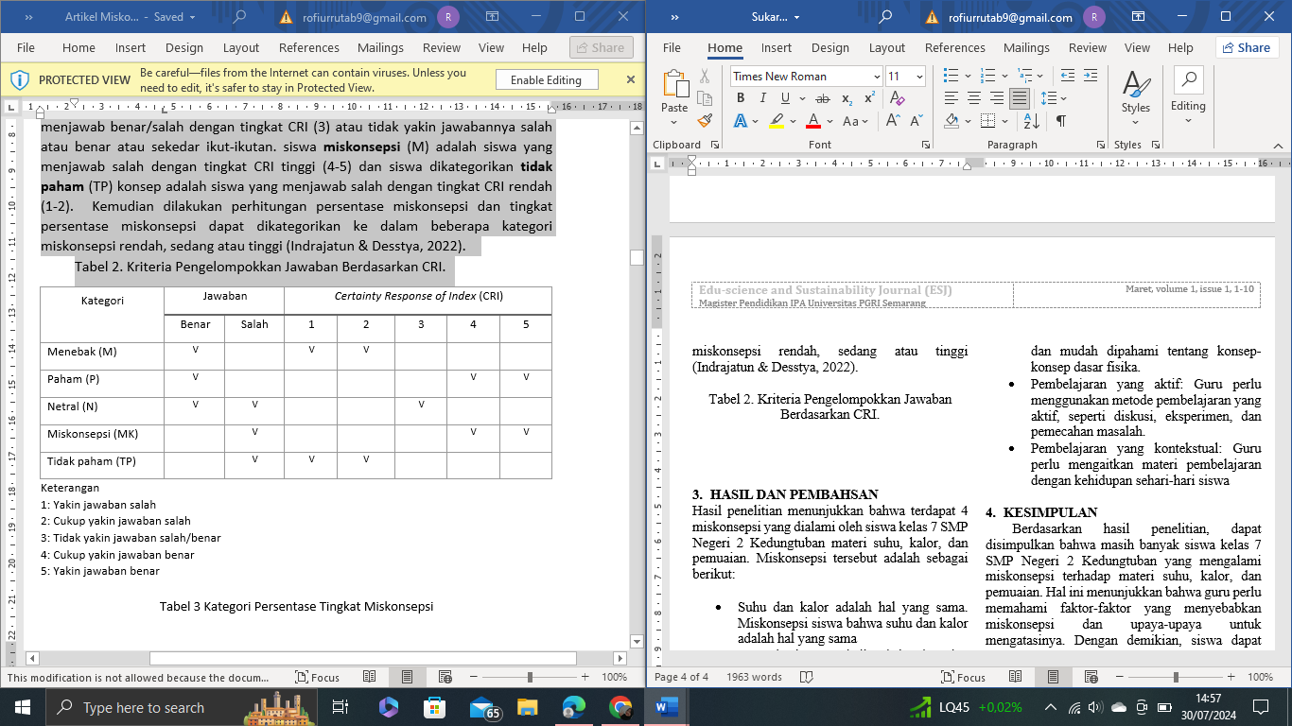

Information

1: Convinced the answer is wrong

2: Be sure the answer is wrong

3: Not sure the answer is wrong/correct

4: Be pretty sure the answer is correct

5: Confident the answer is correct

**Tabel 3**. Category: Percentage of Misconception Rate

|  |  |
| --- | --- |
| **Percentage** | **Category** |
| 0%-30% | Low |
| >30%-60% | Medium |
| >60%-100% | High |

1. **RESULTS AND DISCUSSION**
2. **Description of the results of the investigation**

The description of the score score from the description test given to students is known to have an average of 54.86 with a standard deviation of 17.8. Of the 22 students (N) who scored above average, there were 10 students, the rest or a total of 12 students got scores below average. An explanation of the score of the description test results can be seen in Table 4.

**Tabel 4**. Average Score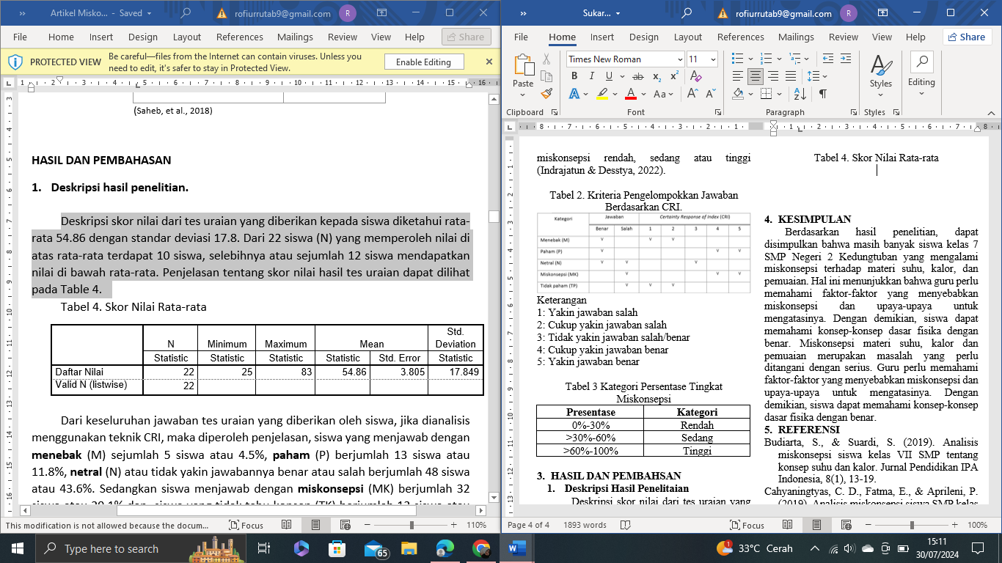

From the overall answer to the description test given by the students, if analyzed using the CRI technique, an explanation was obtained, students who answered by guessing (M) amounted to 5 students or 4.5%, understood (P) amounted to 13 students or 11.8%, neutral (N) or unsure of the correct or incorrect answer amounted to 48 students or 43.6%. Meanwhile, students who answered with misconceptions (MK) amounted to 32 students or 29.1% and students who did not know the concept (TK) amounted to 12 students or 10.9%. The distribution of students' answers from all questions (5 description questions) can be percentaged as shown in Graph 1.

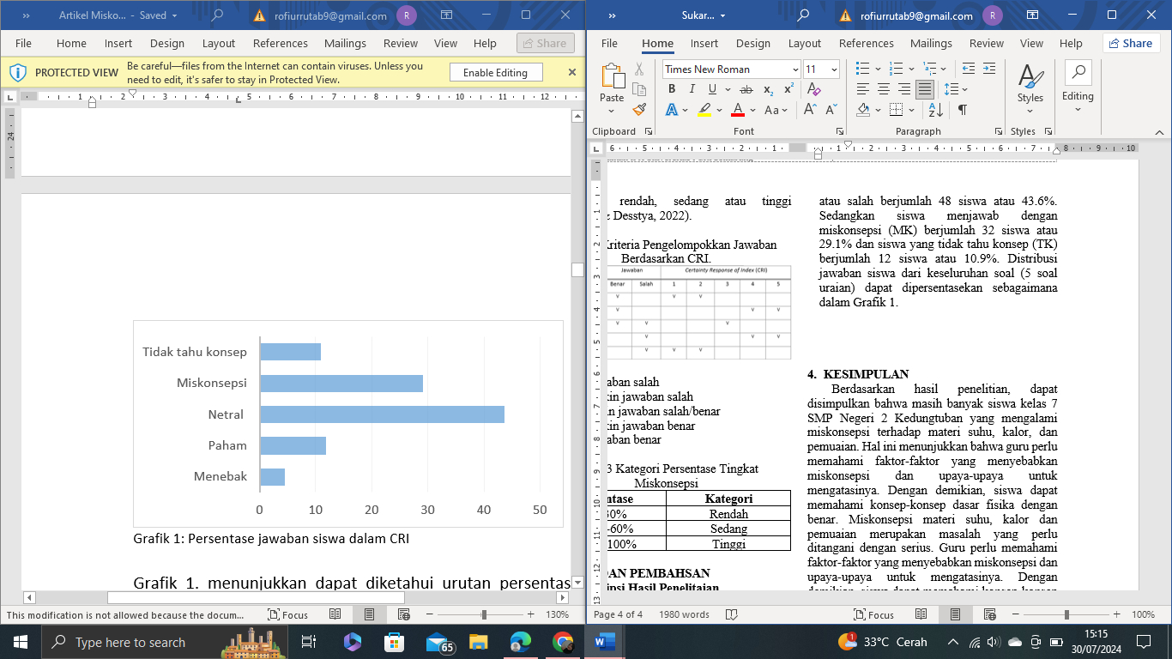**Graph 1**: Percentage of student answers in CRI

Graph 1. shows that it can be seen that the order of the percentage of students' answers in the highest CRI is neutral (N) or wrong/correct answers with CRI (3) amounting to 43.6%. Second, the answers of students who have misconceptions (MK) or wrong answers with CRI (4-5) are 29%. Third, the answers of students who understood (P) or correct answers with CRI (4-5) amounted to 11.8%. Fourth, the answers of students who do not understand the concept (TP) or the wrong answer with CRI (1-2). The five students' answers are original guesses (M) or correct answers with CRI (1-2). From the data on the percentage of students' answers, it shows that the results of science learning in the digestive system have not shown results that are not in accordance with the demands of the curriculum. In the curriculum, it is determined that after students learn the digestive system material, it is hoped that students can understand the concept of the digestive system well, so that the concept can be used in daily life. The percentage of student test results on the digestive system, when viewed from each question given, can be seen in Table 5.

**Table 5**. Percentage of student test results on digestive system material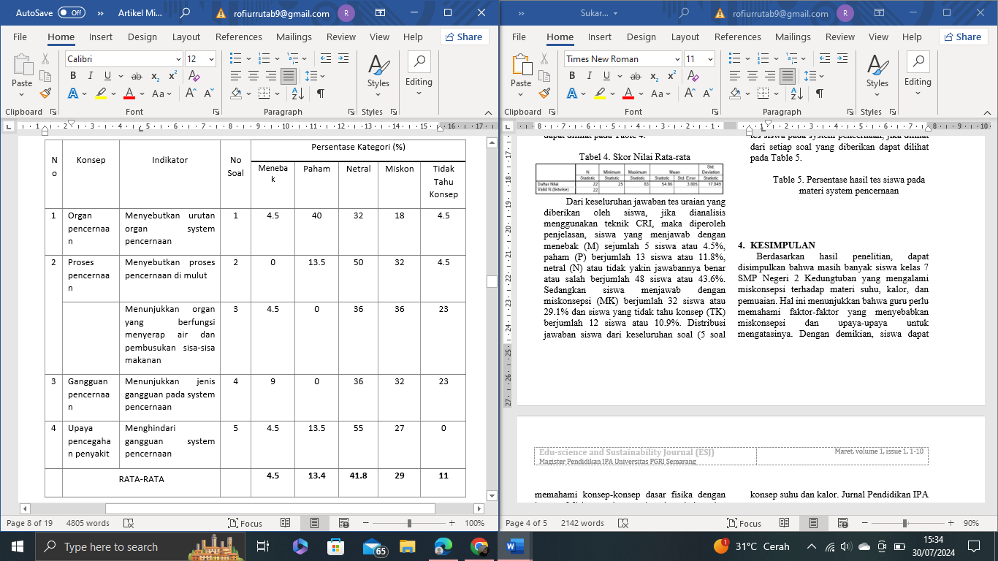

Table 5 shows the percentage of test results of students on the digestive system, in the first question related to mentioning the order of the organs of the digestive system, it is known that the answers of students who guessed were 1 student (4.5%), understanding 9 students (40%), neutral 7 students (32%), misconceptions 4 students (18%) and not knowing the concept of 1 student (4.5%). In the second question, related to the digestive process in the mouth, it was known that the answers of students who guessed were 0 (0%), understood 3 students (13.6%), neutral 11 students (50%), misconceptions 7 students (32%) and did not know the concept of 1 student (4.5%). In the third question related to showing organs that function to absorb water and decay food debris, it was known that the answers of students who guessed were 1 student (4.5%), understand 0 students (0%), neutral 8 students (36%), misconceptions 8 students (36%) and do not know the concept of 5 students (23%). In the fourth question related to Showing the type of disorder in the digestive system, it was known that the answers of students who guessed were 2 students (9%), understand 0 students (0%), neutral 8 students (36%), misconceptions 7 students (32%) and do not know the concept of 5 students (23%). In the fifth question related to Avoiding digestive system disorders, it was known that the answers of students who guessed were 1 student (4.5%), understood 3 students (13.6%), neutral 12 students (55%), misconceptions 6 students (27%) and did not know the concept of 0 students (0%). Furthermore, if table 4 is expressed in the form of a graph that can describe the percentage of students' answers to each question, then the results will be obtained as in Graph 2.

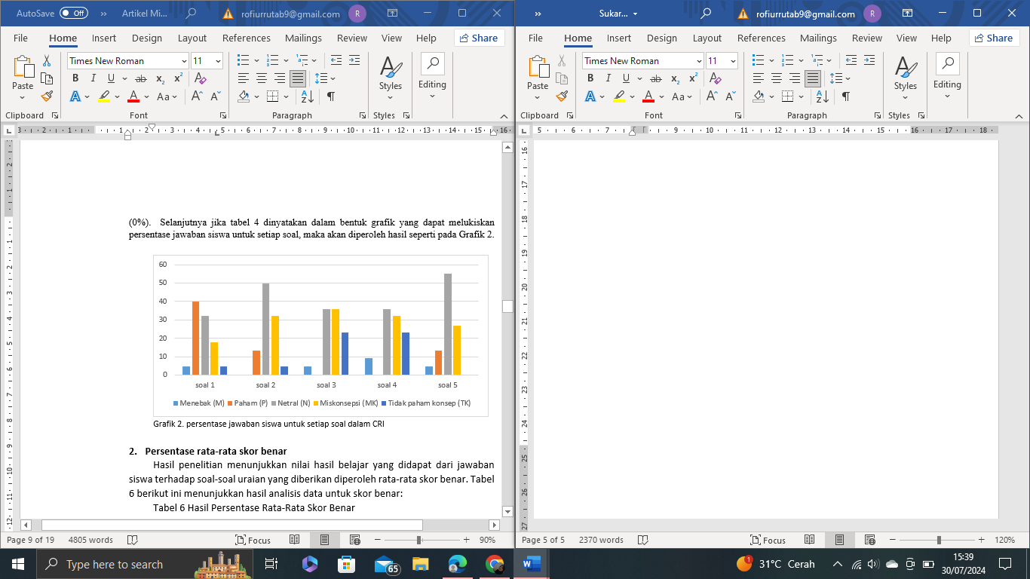

**Grafik 2**. Percentage of student answers to each question in CRI

1. **Average Percentage of Correct Score**

The results of the study showed that the value of learning outcomes obtained from students' answers to the given description questions obtained the average correct score. The following table 6 shows the results of the data analysis for the correct score.

**Table 6**. Results of Average Percentage of Correct Score

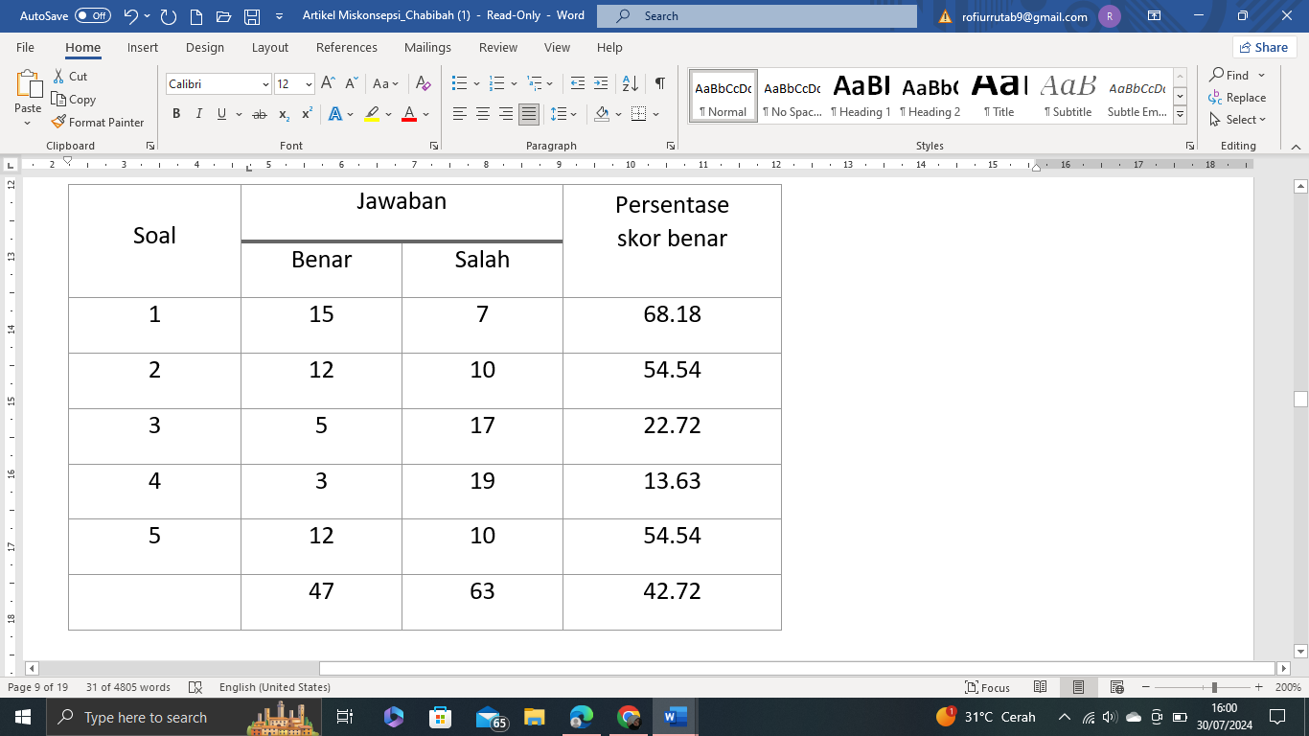

Based on Table 6, it can be seen that the average percentage of students who answered correctly for the first question was 68%, the second question was 54%, the third question was 22%, the fourth question was 13% and the fifth question was 54%, while the average percentage of correct scores for all questions was 42% or those who answered correctly on the digestive system material were classified into the medium category. Furthermore, if table 4 is expressed in the form of a graph that can depict the percentage of students' correct scores for each question, then the results will be obtained as in Graph 3.

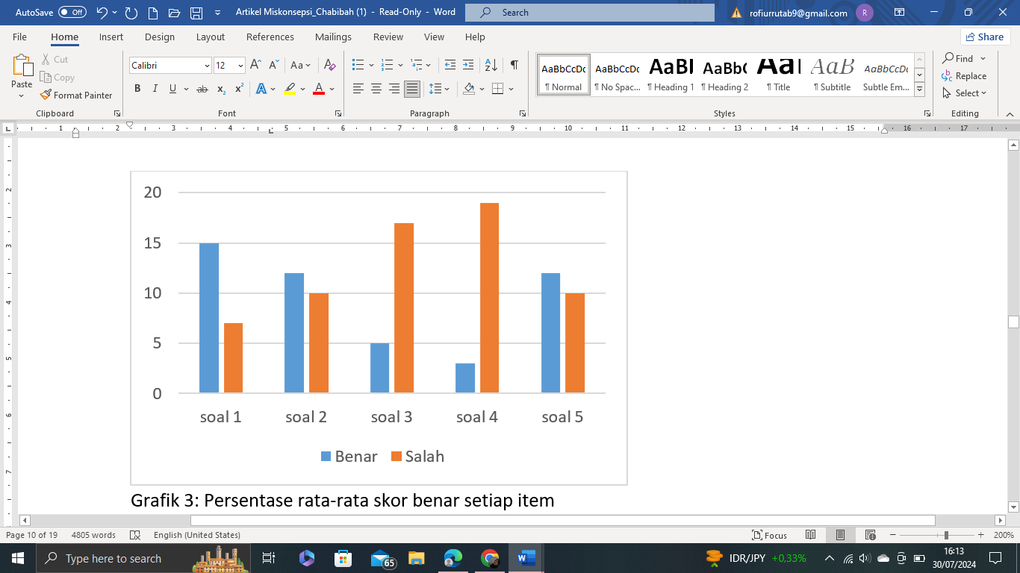

**Graph 3**. The average percentage of correct scores for each item

Based on Graph 3, it can be seen that the order of correct scores from the highest percentage is the correct score for the first question (68%), then the second is occupied for the second and fifth questions respectively (54%), the third for the third question (22%) and the last for the correct score is the fourth question (13%). The average percentage of correct scores for all questions is 42%. This shows that the learning of digestive system science cannot be considered successful because the average correct score is still far from satisfactory. Especially if analyzed using CRI, students who answer correctly cannot be said to understand the concept because there are three possibilities. First, students answered correctly because they understood the concept so they were sure that it was correct or CRI (4-5), the second student answered correctly because they were only guessing or CRI (1-2), and third, students answered correctly because they answered perfunctory because they were not sure that the answer was true/wrong or neutral with CRI (3). Based on the correct score data, it can be explained in Table 7.

**Table 7**. Percentage of correct scores in CRI

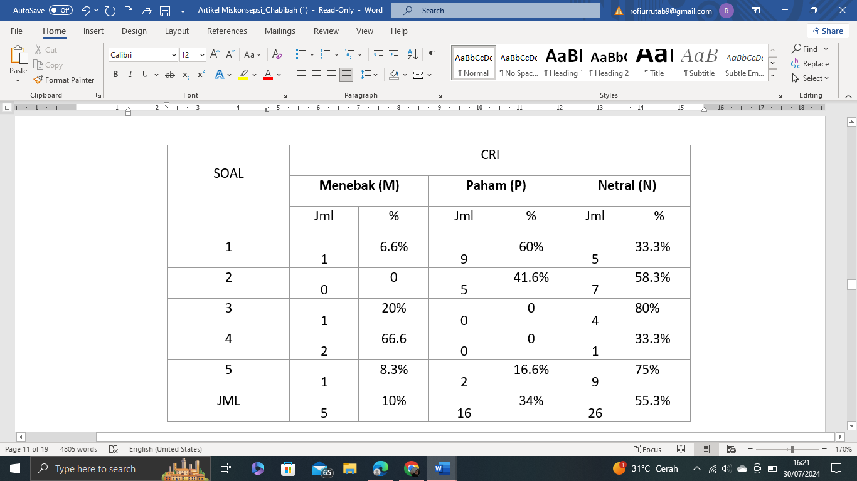

Based on Table 7, it is known that of the students who answered correctly because they understood the concept or who had high confidence that the answer was correct (high CRI) only 34% or in the medium category. While most of the correct answers are actually answered by students but are not sure that the answer is correct/wrong even though the answer is correct 55.3% (high) and the original answer is just guessing, without confidence that the answer is correct 10%. Furthermore, if table 5 is expressed in the form of a graph that can depict the percentage of students' correct scores in the CRI, then the results will be obtained as in Graph 4.

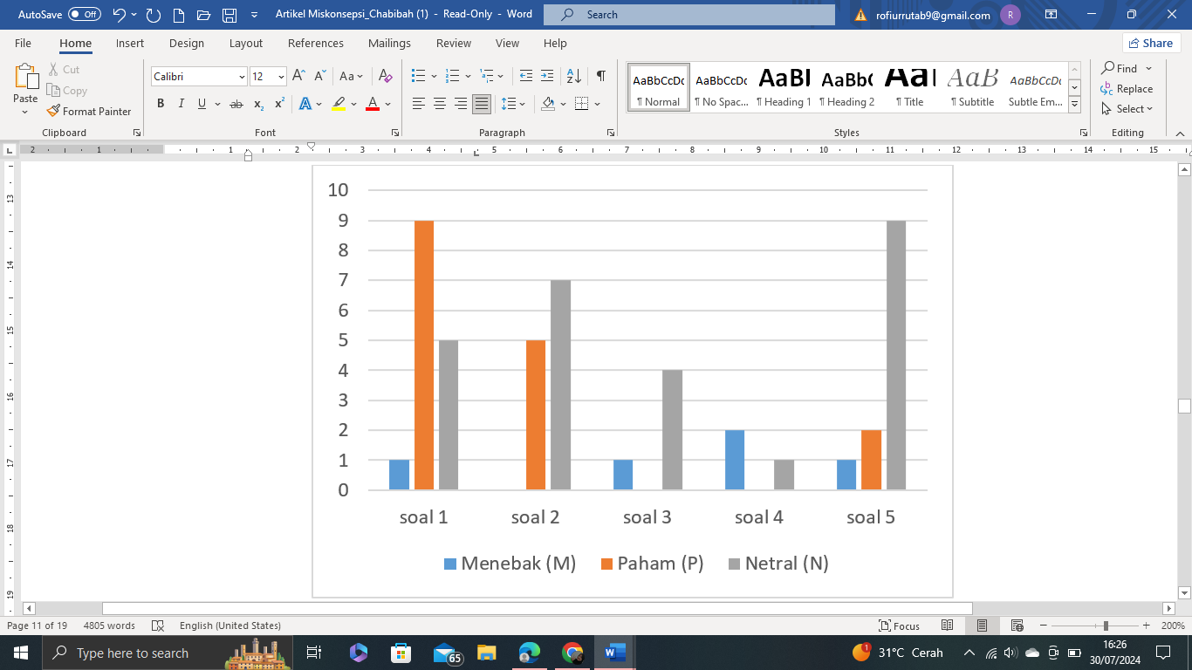Graph 4: Average percentage of correct scores in CRI

Based on Graph 4, it appears that the correct scores of students who understand the concept in a row in the answer to question number 1 (60%), followed by question number 2 (41%), and question number 5 (16.6%). Meanwhile, questions number 4 and number 5 are 0 each. This shows that students' understanding of the concept of the digestive system is not in accordance with the demands of the curriculum so it is necessary to further study the root of the problem that causes the lack of students who understand the concept correctly, especially in questions no. 3 and number 4 where none of the students understand the concept correctly.

1. **Average Percentage of Misconception Score**

Based on Table 5, it is known that the total average percentage of misconceptions experienced by students is 29% or low category. There are four concepts of digestive system material that have been misconceived, namely digestive organs, digestive system processes, digestive system disorders, and efforts to prevent digestive system diseases. The description test carried out had 5 questions using the CRI technique. The average misconception score can be seen in Table 8.

**Tabel 8**. Percentage of misconceptions for each concept and categorization

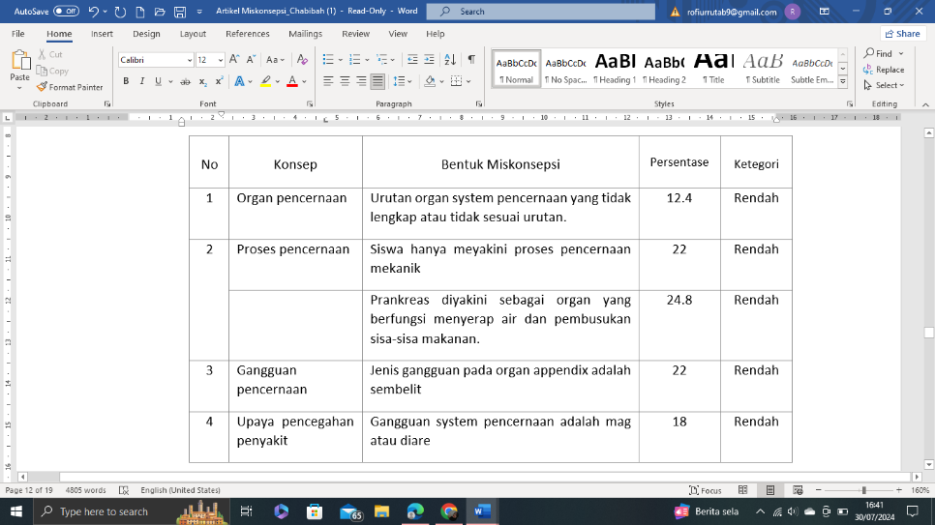

Based on Table 8, it is known that the average misconception experienced by students on the concept of digestive organs is 12.4% with question number 1. The concept of the digestive system process has an average misconception of 23.4% with question numbers 2 and 3. The percentage questions are 22% and 24.8%, respectively. The concept of digestive system disorders has an average misconception of 22% with question number 4. The concept of preventing digestive system disorders has an average misconception of 18% with question number 5. Furthermore, if Table 8 is expressed in the form of a graph that can depict the average percentage of misconception scores, then the results will be obtained as in Graph 5.

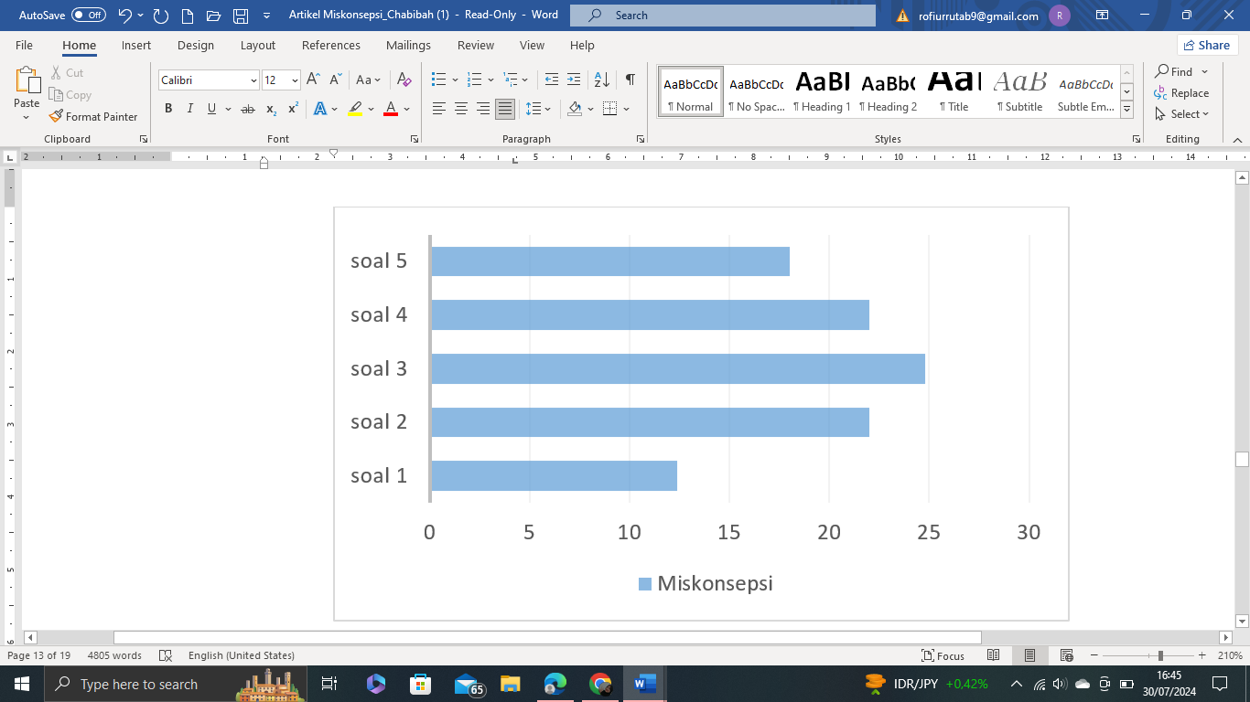

Graph 5: Average percentage of misconception scores

Based on figure 5, it is known that the average score of the most misconceptions in question number 3 is related to the concept of the digestive process (24.8%), then questions number 2 and number 4, related to the concept of the digestive process and the concept of digestive system disorders with 22% each. The third place of misconception scores is question number 5, related to the concept of preventing digestive disorders with 18%. Meanwhile, question number 1, the misconception score is 12.4%, related to the concept of digestive system organs. Based on the picture, it shows that misconceptions occur in all concepts of the digestive system. This is the basis for an in-depth study to uncover the factors that cause misconceptions in each concept of the digestive system.

1. **Factors of Misconception**

Based on observations and interviews, both with students and teachers, it is known that the factors that cause misconceptions in students in general can be distinguished into 2 factors, namely internal students themselves and external, namely teachers, textbooks and learning methods. The factors that cause misconceptions can be seen in Table 9.

Table 9: Factors of misconception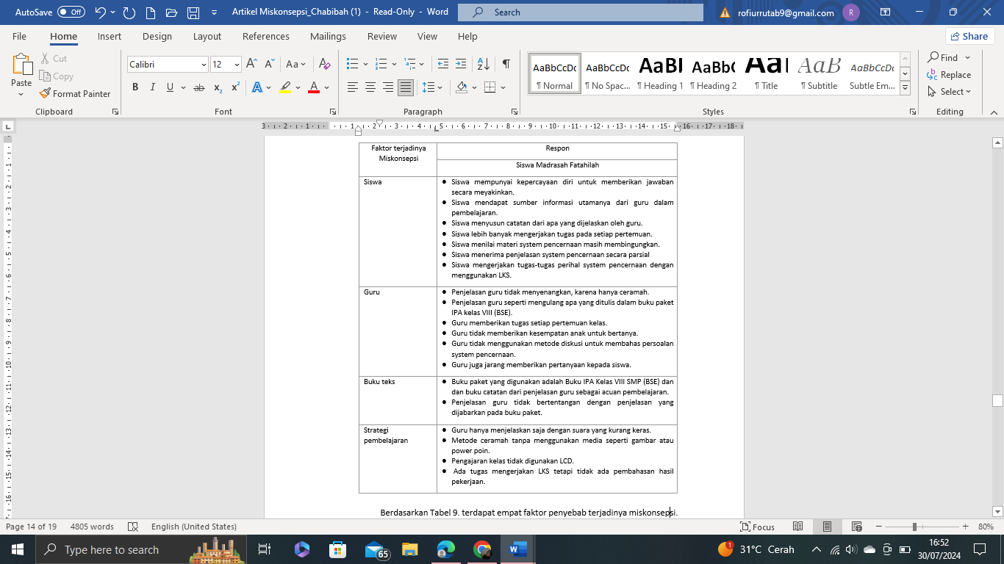

Based on Table 9. There are four factors that cause misconceptions. The factors that cause misconceptions experienced by students are: students themselves, teachers, textbooks, and learning strategies.

Students are one of the factors that cause misconceptions. Students' understanding of the concept of digestive organs is measured through a description test or in question number 1, In the question, students are asked to explain the order of the digestive organs. Based on the results of the students' answers, the percentage of misconceptions was 12.4%. The average misconception student answered 'the order of the digestive system organs is incomplete or not in order'. For example, Widat Akila gave the answer 'stomach, throat and mouth' with CRI (4). The results of Widat's answer indicate a misconception, besides not being sequential, it is also a wrong concept, even with CRI (5). The correct answer, is the mouth, esophagus, stomach, small intestine, colon, and anus.

In question number 2, students are asked to mention the digestive process that occurs in the mouth. Based on the students' answers, the percentage of misconceptions was 22%. The average misconception student answers the mechanical digestive process. For example, Anisa Tsaniatuz Zahra answered mechanical digestion with CRI (5). M. Nabil Husain answered digestion in the mouth, namely biting, chewing and swallowing, with CRI (4). Actually, M. Nabil's answer belongs to the type of mechanical digestive process. The correct answer is that there are two digestive processes in the mouth, namely mechanical and chemical.

In question number 3, students are asked to name the organs where water is absorbed and decayed by decaying bacteria of food waste. Based on the students' answers, the percentage of misconceptions was 24.8%. The average misconception student answered the pancreas or stomach or small intestine. For example, Analul Karomah answered the prankreas, with CRI (4). Anisa Tsaniatuz Zahra answered the stomach with CRI (4). The correct answer is the colon.

In question number 4, students were asked to name the type of disorder in the appendix organs. Based on the students' answers, the percentage of misconceptions was 22%. The average misconception student answered constipation or diarrhea or ulcers. For example, Analul Karomah answered constipation with CRI (4). Anisa Tsaniatuz Zahra answered diarrhea with CRI (5). Elvina answered the ulcer with CRI (5). The correct answer is appendicitis.

In question number 5, students were asked about efforts to prevent constipation. Based on the students' answers, the percentage of misconceptions was 18%. The average student misconception answered that eating fruits can prevent diarrhea or ulcers. For example, Analul Karomah answered that eating fruits can prevent diarrhea with CRI (5). Anisa Tsaniatuz Zahro answered that eating vegetables and fibrous foods can prevent ulcers with CRI (5). The correct answer is that eating more fruits, vegetables and fibrous foods can prevent constipation.

The high percentage of students who are deceived in answering questions indicates that there is a problem in students' ability to analyze questions correctly. This can contribute to the emergence of misconceptions. Misconceptions often begin with students' initial thoughts. Therefore, it is important for teachers to understand students' initial understanding and work closely with them to establish the correct concepts.

Students' understanding is also influenced by teacher factors and teaching methods. Teachers play a key role in the success of student understanding. The teacher's inability to explain the material in its entirety can be the cause of misconceptions in students. If teachers are unable to use less effective learning methods, students may have difficulty understanding the material. It is important for educators and education actors to continue to develop effective teaching strategies, pay attention to in-depth explanation of concepts, and actively identify and overcome student misconceptions so that learning is more effective and concept understanding is more accurate.

Textbooks that are inaccurate or unclear in explaining concepts can lead to misconceptions. Therefore, the selection of good and clear textbooks is very important in supporting student understanding. In addition to accuracy, readability and clarity are also important. Textbooks that are difficult to understand or lack clarity in explaining concepts can make it difficult for students to understand the material and increase the risk of misconceptions. The use of old or unrevised textbooks can also create a risk of misconceptions. Learning materials can evolve, and textbooks that are not updated may not include up-to-date information or better explanations. Teachers play an important role in evaluating textbooks before they are used in learning. Ensuring the accuracy, readability, and clarity of textbooks is the responsibility of teachers as learning facilitators. By paying attention to the quality of the textbooks used in teaching, teachers can improve the effectiveness of learning and assist students in understanding concepts without unwanted misconceptions.

1. **Implications and Recommendations**

**Implication**

The implications of this study include:

1. Identifying misconceptions can help teachers in adjusting teaching strategies.
2. Commonly identified misconceptions can provide input for curriculum adjustments.
3. Identifying misconceptions helps guide teachers in providing more personalized guidance to students.
4. The results of the identification of misconceptions can be a valuable contribution to educational research.
5. By proactively identifying and responding to misconceptions, teachers can improve the quality of learning, improve student understanding, and create a more effective learning environment.

**Recommendations**

Based on the results of the research, the researcher proposed the following recommendations:

1. Increase quizzes or formative tests to test students' understanding of digestive system material.
2. Have a group discussion or class discussion about the concepts of the digestive system.
3. Provide open-ended questions that encourage students to detail their understanding of the digestive system.
4. Use practicum activities or demonstrations to give students hands-on experience with digestive system material.
5. Give assignments to projects that require students to investigate certain aspects of the digestive system.
6. Review students' answers on tests or assignments and look for consistent patterns of error.
7. **CONCLUSION**

Based on the results of the analysis and discussion, it can be concluded that:

1. The average percentage of misconceptions experienced by students is 29% or a low category. There are four concepts of digestive system material that have been misconceived, namely digestive organs (12.4%), digestive system processes (23.4%), digestive system disorders (22%), and efforts to prevent digestive system diseases (18%).
2. The factors that cause misconceptions come from students, teachers, textbooks and teachers' learning strategies.
3. **REFERENCE**

Alon, U. (2009). How To Choose a Good Scientific Problem. *Molecular Cell*, *35*(6), 726–728.

Aaliyah, R. (2017). Profil Miskonsepsi Siswa Pada materi Sistem Pencernaan Kelas XI SMA. *Berkala Ilmiah Pendidikan Biologi Vol.*, *6*(3), 304–310. http://ejournal.unesa.ac.id/index.php/bioedu

Chania Rosi, L. F. (2014). Identifikasi Miskonsepsi Guru Biologi SMA Kelas XI IPA Pada Konsep Sistem Reproduksi Manusia. *Jurnal EduBio Tropika*, *2*(2), 187–191.

Chaterine Dawson. (2002). *Practical Research Methods: A User-friendly Guide to Mastering Research*.

Hapsari, I. S., Karyanto, P., & Sunarno, W. (2016). *Penggunaan Diagram Vee Untuk Menganalisis Miskonsepsi*. 50–54.

Indrajati, D. A. R., & Destya, A. (2022). Analisis Miskonsepsi Materi Sistem Pencernaan Manusia Menggunakan Certainty of Response Index di Sekolah Dasar. *Jurnal Basicedu*, *6*(4), 6345–6353. https://doi.org/10.31004/basicedu.v6i4.3244

Istikomayanti, Y., & Mitasari, Z. (2017). Student’s misconception of digestive system materials in MTs eighth grade of Malang city and the role of teacher’s pedagogical competence in MTs. *JPBI (Jurnal Pendidikan Biologi Indonesia)*, *3*(2), 103–113. https://doi.org/10.22219/jpbi.v3i2.4326

Iwantara, I., Sadia, I., & Suma, I. (2014). Pengaruh Penggunaan Media Video Youtube Dalam Pembelajaran IPA Terhadap Motivasi Belajar Dan Pemahaman Konsep Siswa. *E-Journal Program Pascasarjana Universitas Pendidikan Ganesha Program Studi IPA*, *4*(1), 1–13. https://www.neliti.com/id/publications/122399/pengaruh-penggunaan-media-video-youtube-dalam-pembelajaran-ipa-terhadap-motivasi

Karpudewan, M., Roth, W. M., & Chandrakesan, K. (2015). Remediating misconception on climate change among secondary school students in Malaysia. *Environmental Education Research*, *21*(4), 631–648. https://doi.org/10.1080/13504622.2014.891004

Liu, G., & Fang, N. (2023). The effects of enhanced hands-on experimentation on correcting student misconceptions about work and energy in engineering mechanics. *Research in Science and Technological Education*, *41*(2), 462–481. https://doi.org/10.1080/02635143.2021.1909555

Maison, M., Lestari, N., & Widaningtyas, A. (2020). Identifikasi Miskonsepsi Siswa Pada Materi Usaha Dan Energi. *Jurnal Penelitian Pendidikan IPA*, *6*(1), 32–39. https://doi.org/10.29303/jppipa.v6i1.314

Safitri et al. (2018). Analisis Kesesuaian Tujuan Kurikulum Pada Buku Teks Pelajaran Ipa Smp / Mts Kelas Vii Semester 2 Untuk Diintegrasikan Dengan Materi Tsunami Universitas Negeri Padang. *Pillar of Physics Education*, *11*(2), 9–16. http://ejournal.unp.ac.id/students/index.php/pfis/article/view/3297

Sholihat, F. N., Samsudin, A., & Nugraha, M. G. (2017). Identifikasi Miskonsepsi dan Penyebab Miskonsepsi Siswa Menggunakan Four-Tier Diagnostic Test Pada Sub-Materi Fluida Dinamik: Azas Kontinuitas. *Jurnal Penelitian & Pengembangan Pendidikan Fisika*, *3*(2), 175–180. https://doi.org/10.21009/1.03208

Suwono, H., Prasetyo, T. I., Lestari, U., Lukiati, B., Fachrunnisa, R., Kusairi, S., Saefi, M., Fauzi, A., & Atho’Illah, M. F. (2021). Cell Biology Diagnostic Test (CBD-Test) portrays pre-service teacher misconceptions about biology cells. *Journal of Biological Education*, *55*(1), 82–105. https://doi.org/10.1080/00219266.2019.1643765

Trotskovsky, E., & Sabag, N. (2015). One output function: a misconception of students studying digital systems – a case study. *Research in Science and Technological Education*, *33*(2), 131–142. https://doi.org/10.1080/02635143.2014.983468